Software Engineering

Assignment 1

Output

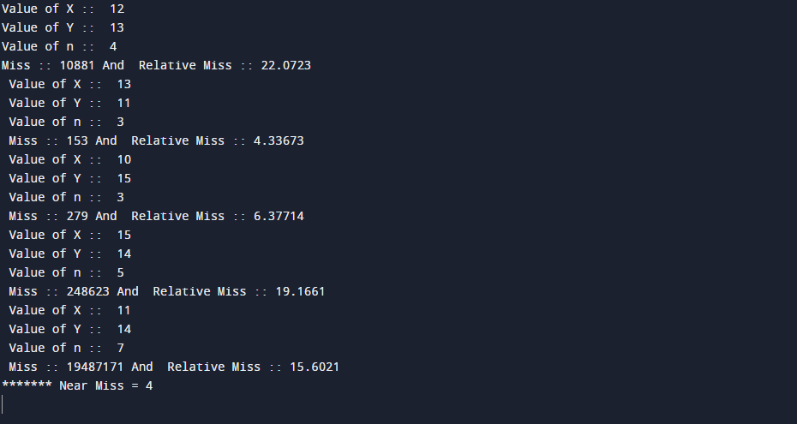

Code:

// Looking for Fermat's Last Theorem

// Programmer Name 1: Naveen Madupoju

// Programmer Name 2: Praneeth Somisetty

//Programmer 1 EmailAddress: NaveenMadupoju@lewisu.edu

//Programmer 2 EmailAddress: PraneethSomisetty@lewisu.edu

// In this program we are calculatibng the equation and finding the nearest miss

#include <iostream>

#include <math.h>

using namespace std;

int main() {

int arr[5];

int x,y,z,n;

int lowerk = 10;

int upperk = 15;

bool flag = false;

//solving the equations 5 times, with different values of x, y and n

for (int i =0; i<5; i++)

{

//While loop to check either user input for x is in range

while(flag!=true)

{

cout<<" Value of X :: ";

cin>>x;

//condition to check range

if(x>=lowerk && x<=upperk)

{

flag = true; // if flag will be true it means user input is accurate

}

}

flag = false;

//While loop to check either user input for y is in range

while(flag!=true)

{

cout<<" Value of Y :: ";

cin>>y;

//condition to check range

if(y>=lowerk && y<=upperk)

{

flag = true; // if flag will be true it means user input is accurate

}

}

flag = false;

//While loop to check either user input for n is greater than 2

while(flag!=true)

{

cout<<" Value of n :: ";

cin>>n;

if(n>2)

{

flag = true; // if flag will be true it means user input is accurate

}

}

flag = false;

//This chunk of code is main logic of the code

//Where equation is being solved

long sumxy = (int) (pow (x, n) + pow (y, n));

z = (int) pow (sumxy, 1.0/n);

//Calculating the near miss

int miss = sumxy - pow (z, n);

//calculating the relative miss

double relativemiss = 100. \* miss / sumxy;

//Output

cout<<"Miss :: "<< miss <<" And Relative Miss :: "<<relativemiss<<endl;

//Array to store the result of relative near miss everytime

//So that at the end we can find out the smallest nearest miss

arr[i]=relativemiss;

}

int nearmiss;

//to find out the smallest vlaue from the list of near miss, That will be our nearest miss

for(int i = 0; i < 5; i++)

{

if(arr[i] < nearmiss)

{

nearmiss = arr[i];

}

}

cout<<"\*\*\*\*\*\*\* Near Miss = "<<nearmiss<<endl;

return 0;

}